**NAME: SIDDHI SUBHEDAR**

**PRN: 1262240621**

**TIME SERIES DATA IN R**

install.packages("lubridate")

install.packages("forecast")

library(lubridate)

library(forecast)

x <- c(580, 7813, 28266, 59287, 75700, 87820, 95314,

126214, 218843, 471497, 936851, 1508725, 2072113)

mts <- ts(x, start = decimal_date(ymd("2020-01-22")), frequency = 365.25 / 7)

png(file = "timeSeries.png") # Save as PNG file

plot(mts, xlab = "Weekly Data", ylab = "Total Positive Cases",

main = "COVID-19 Pandemic", col.main = "darkgreen")

dev.off()

RStudioGD

2

deaths <- c(17, 270, 565, 1261, 2126, 2800, 3285,

4628, 8951, 21283, 47210, 88480, 138475)

mts_multi <- ts(cbind(positiveCases = x, deaths = deaths),

start = decimal_date(ymd("2020-01-22")), frequency = 365.25 / 7)

png(file = "multivariateTimeSeries.png")

plot(mts_multi, xlab = "Weekly Data", main = "COVID-19 Cases",

col.main = "darkgreen")

dev.off()

RStudioGD

2

fit <- auto.arima(mts)

forecasted_values <- forecast(fit, h = 5)

png(file = "forecastTimeSeries.png")

plot(forecasted_values, xlab = "Weekly Data", ylab = "Total Positive Cases",

main = "COVID-19 Pandemic Forecast", col.main = "darkgreen")

dev.off()

print(forecasted_values)

Point Forecast Lo 80 Hi 80 Lo 95 Hi 95

2020.307 2547989 2491957 2604020 2462296 2633682

2020.326 2915130 2721277 3108983 2618657 3211603

2020.345 3202354 2783402 3621307 2561622 3843087

2020.364 3462692 2748533 4176851 2370480 4554904

2020.383 3745054 2692884 4797225 2135898 5354210

getwd()

> getwd()

[1] "C:/Users/SoECE/Documents"

plot(mts, xlab = "Weekly Data", ylab = "Total Positive Cases",

main = "COVID-19 Pandemic", col.main = "darkgreen")

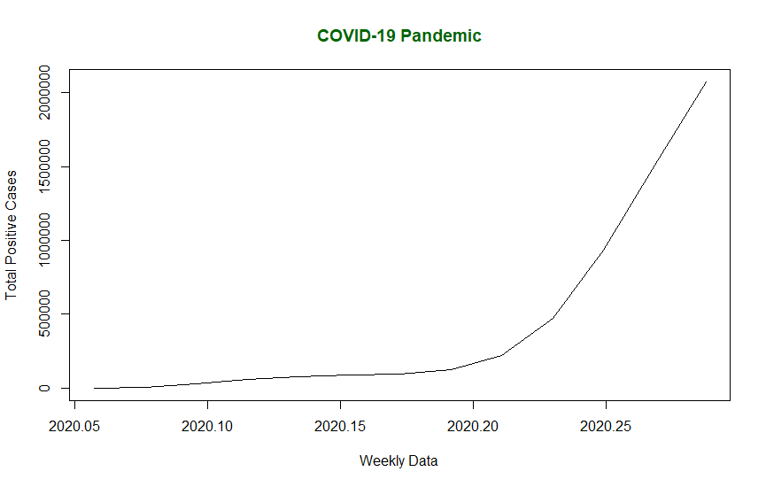

plot(forecasted_values, xlab = "Weekly Data", ylab = "Total Positive Cases",

main = "COVID-19 Pandemic Forecast", col.main = "darkgreen")

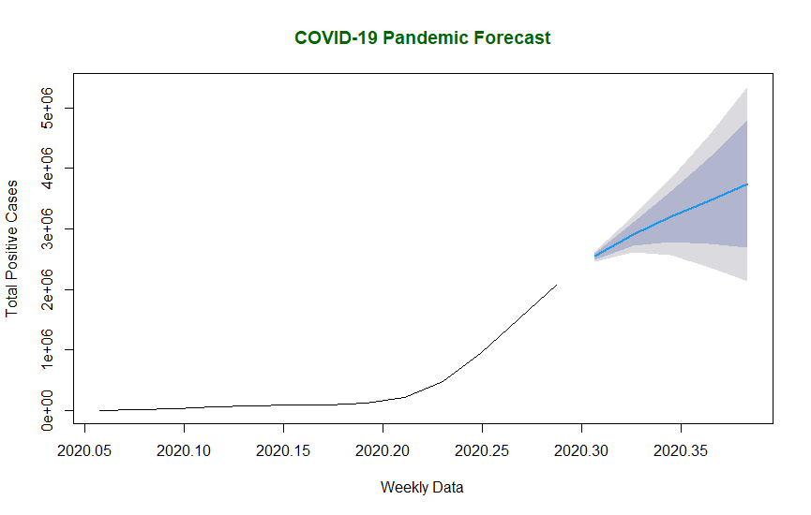

# Save as JPEG

jpeg(file = "timeSeries.jpg")

plot(mts, xlab = "Weekly Data", ylab = "Total Positive Cases",

main = "COVID-19 Pandemic", col.main = "darkgreen")

dev.off()

# Save as PDF

pdf(file = "timeSeries.pdf")

plot(mts, xlab = "Weekly Data", ylab = "Total Positive Cases",

main = "COVID-19 Pandemic", col.main = "darkgreen")

dev.off()

# Test the PNG device

png(file = "testPlot.png")

plot(1:10, main = "Test Plot") # Simple plot for testing

dev.off()

# View the saved image in R

library(png)

library(grid)

img <- readPNG("timeSeries.png")

grid.raster(img)

update.packages()